Product: Yoga With Adriene videos (available on YouTube)
Slogan: Do “Me Time” on Your Time

FADE IN:

INT. SUN-LIT LIVING ROOM. MONOCHROMATIC COLORS (BEIGE, WHITE). MORNING.

Establishing shot: A bright blue yoga mat unrolls across the floor. Tranquil, spa-like music plays. The camera pans across the room, establishing the room’s role as peaceful sanctuary. An essential oil diffuser, a bouquet of flowers in a vase, etc. A WOMAN, mid-30s, dressed in black yoga pants and a form-fitting T-shirt, sits cross-legged on the mat, her hands in prayer position.

She inhales….

DAUGHTER (OFF-SCREEN):

…. “MOOOOOMMMMYYYYYYY!!!!!!!!!!!!!!!” (Audio: Record scratch sound effect on the tranquil music, switching to Brandi Carlile’s “The Mother”)

CUT TO:

A close-up of the WOMAN’s eyes popping open.

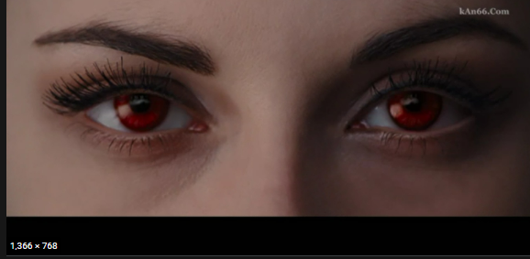

CUT TO:
The WOMAN, with a forced smile on her face, still in her yoga clothes, having a play tea party in her four-year-old DAUGHTER’s room. The room is bright pink, with dolls, stuffed animals and toy crates. In the middle sits a medium-sized table, laid out with an ornate plastic tea set. The DAUGHTER and WOMAN are both wearing tiaras.

DAUGHTER, handing the WOMAN a plastic teacup and saucer:
“Here’s your tea, Mommy!”
The WOMAN closes her eyes, takes a deep breath, and “sips” her tea.
CUT TO:
The WOMAN, back in cross-legged position, hands in prayer.

DAUGHTER (OFF-SCREEN):
“MOMMYYY!!!! CAN I HAVE SOME LUNCH?”

CUT TO:
The WOMAN in the kitchen, in deep concentration as she makes a grilled cheese sandwich and cuts up carrots and celery. As she brings her daughter’s lunch plate to the table, she quickly glances at the still-untouched yoga mat in the living room.

CUT TO:
The WOMAN, back in cross-legged position, hands in prayer. Within seconds she’s interrupted again.

DAUGHTER (OFF-SCREEN):
“MOMMY!!! CAN WE GO TO THE PARK?”
CUT TO:
A montage of the WOMAN pushing the DAUGHTER on the swings, helping her climb on the jungle gym, and helping her slide down the slide. At this point, she’s wearing a jacket covering her yoga garb, and her daily practice has all been forgotten. The montage then fades into the evening, where the WOMAN is back in the kitchen, cooking dinner. As the WOMAN walks toward the dinner table, she glances again at the untouched yoga mat, now collecting dust in the dark living room. Her eyes convey disappointment.

CUT TO:
Another montage of the WOMAN reading Brown Bear, Brown Bear What Do You See? to the DAUGHTER in bed, before tucking the DAUGHTER in and kissing her goodnight. The WOMAN is wearing a zip-up hoodie, and the yoga pants from earlier. She yawns as she exits the DAUGHTER’s room, and solemnly walks down the hall back to the living room.
She slowly unzips the hoodie and removes it, revealing she’s been wearing the same yoga garb underneath the entire day. The untouched yoga mat is still there, on the floor. The WOMAN flicks on a couple of lights, and then reaches for her TV remote.
The YouTube logo flashes onscreen:

The WOMAN, once again, is seated in front of the screen, her legs crossed, her hands in prayer, but this time, she’s smiling.
AUDIO CUE:
(At this point, “The Mother” stops playing.)
FEMALE VOICE-OVER (ADRIENE MISHLER OF YOGA WITH ADRIENE):
“Hi everyone, welcome to Yoga With Adriene, I’m Adriene…”

CUT TO:
The TV screen featuring a video of Adriene sitting on her yoga mat snuggling with her dog, Benji.
ADRIENE VOICE-OVER:
“…And this is Benji.”
The WOMAN proceeds to finally do her yoga practice: We see a montage of her doing planks, downward-facing dogs, tree poses, cat and cow poses, etc. She is smiling the entire time.

FEMALE VOICE-OVER (ADRIENE MISHLER HERSELF WOULD BE PERFECT):
“Do ‘Me Time’ on your time. Yoga With Adriene videos are available for free, 24/7 on YouTube.com. Find what feels good.”

