THE ANTI-GOOP
Wellness that works – and doesn’t work
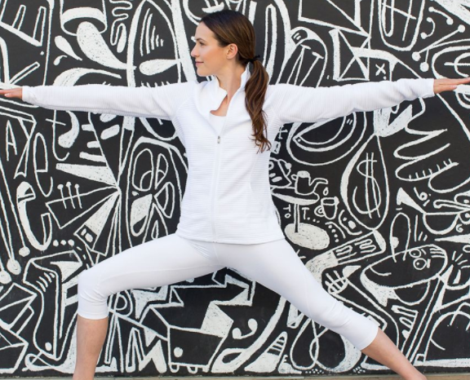
Get to Know the Real “Yoga With Adriene”
If you attempted at-home yoga during the pandemic, it’s more than likely you tried out a “Yoga With Adriene” video or two. But who is Adriene Mishler, the woman behind the 10 million-subscriber-strong YouTube channel? Turns out she’s all the things she exemplifies in her videos: Someone who’s genuinely holding a safe space for you online.

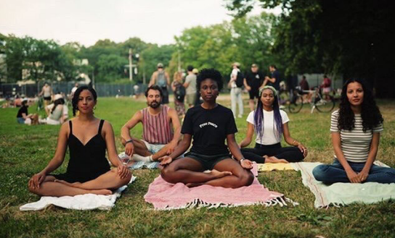

Meditation as Motivation
Brittany Micek started the grassroots organization Meditating for Black Lives at
the height of the 2020 Black Lives Matter resurgence. It was her belief that engaging in self-care, like meditation, could help heal the trauma that went hand-in-hand with BLM protests. More than a year later, Meditating for Black Lives is struggling to maintain its initial momentum, but Micek isn’t giving up on meditation’s power of motivation.

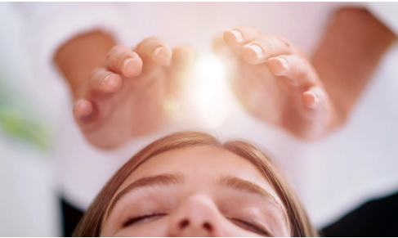
What Is “Distance” Reiki?
COVID may have slowed down in-person wellness treatments, but plenty of practitioners, like Reiki Master Frances Naude, adapted to their new circumstances by offering virtual energy-healing sessions. Elena Nicolaou shares her first-hand account of receiving distance reiki from Naude – while both women were on opposite coasts.

ASMR: Passing Fad or Legit Calming Tool?
Whispery, finger-tapping videos triggering the tingly sensation known as autonomous sensory meridian response, or ASMR, have exploded online in the past decade. While brands and celebrities were quick to join Team Tingles, the science behind ASMR – and its future as an authentic movement – remains murky.
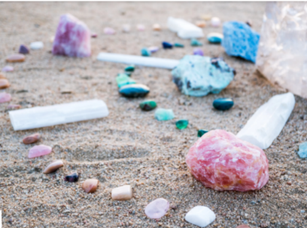
The Truth About Healing Crystals
After a year and a half of living in a pandemic, we’re willing to latch on to anything that gives us comfort and positive vibes. Enter crystals, with their myriad colors, jagged edges, and claims of therapeutic properties. Although this billion-dollar business has seen an uptick in searches since COVID hit, buyer beware: Science experts say crystals don’t contain any healing elements.

